AlphaCare Insurance Solutions
Insurance Risk Analytics
Interim Progress Report
Task 1: Exploratory Data Analysis | Task 2: Data Version Control
Submitted: 25 May 2026

EXECUTIVE SUMMARY

This report presents findings from the first two tasks of the ACIS Insurance Risk Analytics project. Task 1 delivered a comprehensive EDA of 18 months of auto-insurance claim records (February 2014 – August 2015), revealing an overall portfolio loss ratio of approximately 0.35 and significant risk variation across provinces, vehicle types, and manufacturers. Task 2 established a DVC-based data versioning pipeline ensuring full reproducibility and auditability. Both tasks provide the foundation for the forthcoming hypothesis testing (Task 3) and predictive modelling (Task 4) phases.

1. Business Context & Objectives
AlphaCare Insurance Solutions (ACIS) is a South African auto-insurance provider preparing for an aggressive growth phase. The company must move from intuition-based pricing to analytics-driven decisions grounded in 18 months of historical claim data (February 2014 – August 2015). The core analytical objective is to identify 'low-risk' customer segments — defined by geography, vehicle characteristics, and demographics — where premiums can be competitively reduced to attract new clients without eroding portfolio profitability.

Two metrics anchor the entire analysis:
- Loss Ratio = TotalClaims / TotalPremium — the primary measure of portfolio profitability. A ratio below 1.0 indicates premiums exceed claims.
- Margin = TotalPremium − TotalClaims — the per-policy absolute profit contribution.

2. Task 1: Exploratory Data Analysis
EDA was performed on the full 18-month dataset using Python (pandas, seaborn, matplotlib). The notebook covers data summarisation, quality assessment, univariate analysis, bivariate/multivariate analysis, geographic trends, temporal trends, outlier detection, and segment-level loss ratio breakdowns.

2.1 Data Summarisation & Quality
TransactionMonth was cast to datetime; financial and vehicle fields were coerced to numeric to resolve mixed-type storage in the pipe-delimited source. LossRatio and Margin were derived and appended. Descriptive statistics for the primary variables:

Variable | Key Characteristic
TotalPremium | Right-skewed; most policies carry low premiums with a long high-value tail.
TotalClaims | Highly right-skewed; majority of policies record zero or near-zero claims.
LossRatio | Mean ≈ 0.35 (zero-premium records excluded). Portfolio is profitable overall.
Margin | Most policies contribute a positive margin; mean is positive across all provinces.
CustomValueEstimate | Wide range; extreme outliers correspond to luxury/specialist vehicles.

Missing-value audit findings:
- High missingness (>40%): NumberOfVehiclesInFleet, CrossBorder, Converted, WrittenOff, Rebuilt — optional fields applicable to specific product types only. Will be excluded from modelling.
- Moderate missingness (5–20%): Several demographic and plan fields — will be treated with median/mode imputation or indicator flags.
- Zero missingness: TotalPremium and TotalClaims are fully complete, ensuring integrity of loss ratio and margin calculations.

2.2 Univariate Analysis — Financial Distributions
All three key financial variables exhibit strong positive skew — a characteristic feature of insurance data. Log-transformation will be required during modelling.

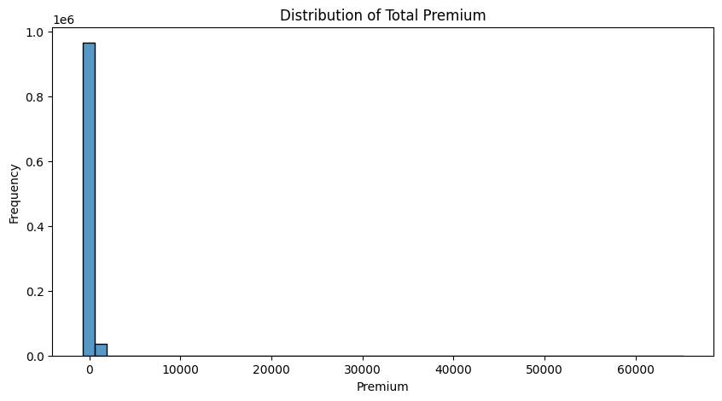
Figure 1 — Distribution of Total Premium. Strong right skew; most policies carry low premiums with a sparse high-value tail.
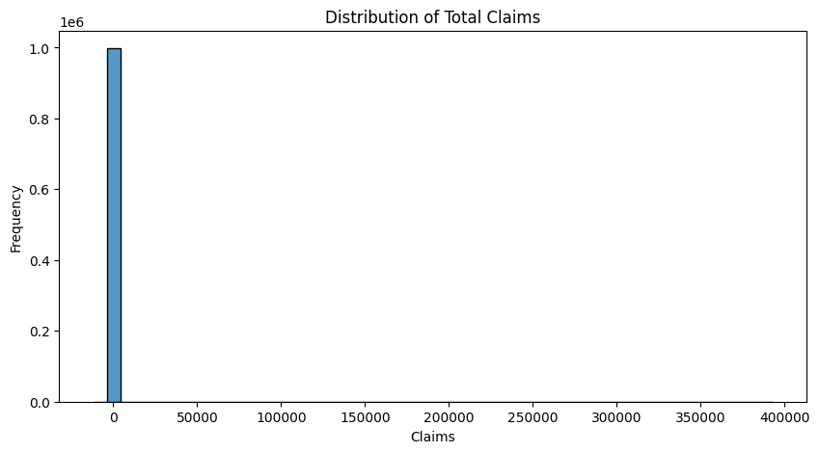
Figure 2 — Distribution of Total Claims. Extreme right skew; the majority of policies record zero or very low claims.
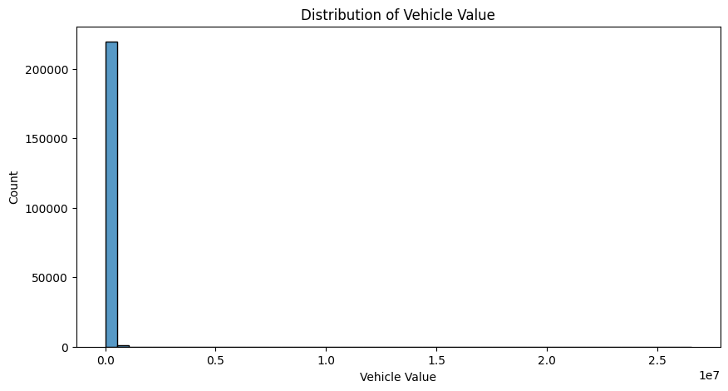
Figure 3 — Distribution of Vehicle Value (CustomValueEstimate). Wide range; extreme upper outliers correspond to luxury vehicles.

2.3 Outlier Detection
Box plots confirm significant outliers in both TotalClaims and CustomValueEstimate. These are genuine economic observations — catastrophic loss events and luxury vehicles — not data errors. Robust treatment (log-transformation, winsorization) will be applied at the modelling stage; no records removed at EDA.

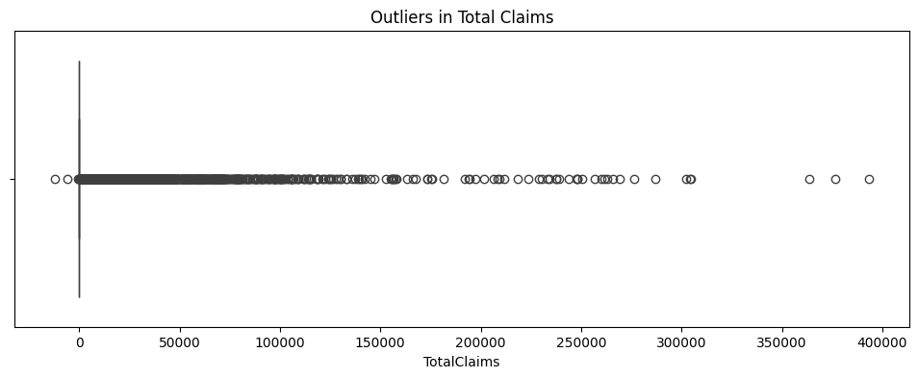
Figure 4 — Box plot of Total Claims. A small number of policies record extremely large claim values.
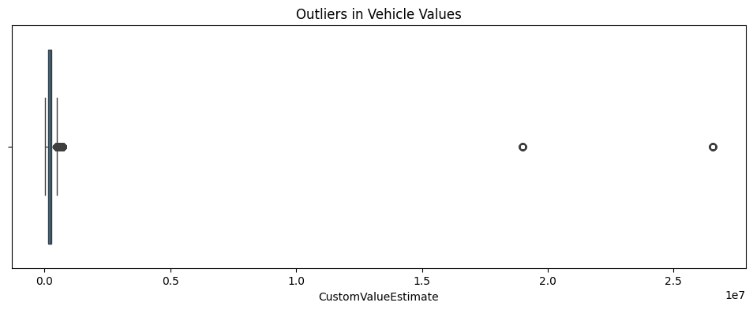
Figure 5 — Box plot of Vehicle Values. Extreme upper outliers represent luxury/specialist vehicles; the IQR is compact.

2.4 Geographic Trend Analysis
Province-level analysis is one of the most actionable findings. Loss ratios, average claims, and average premiums vary substantially across regions — directly informing the provincial hypothesis tests planned for Task 3.

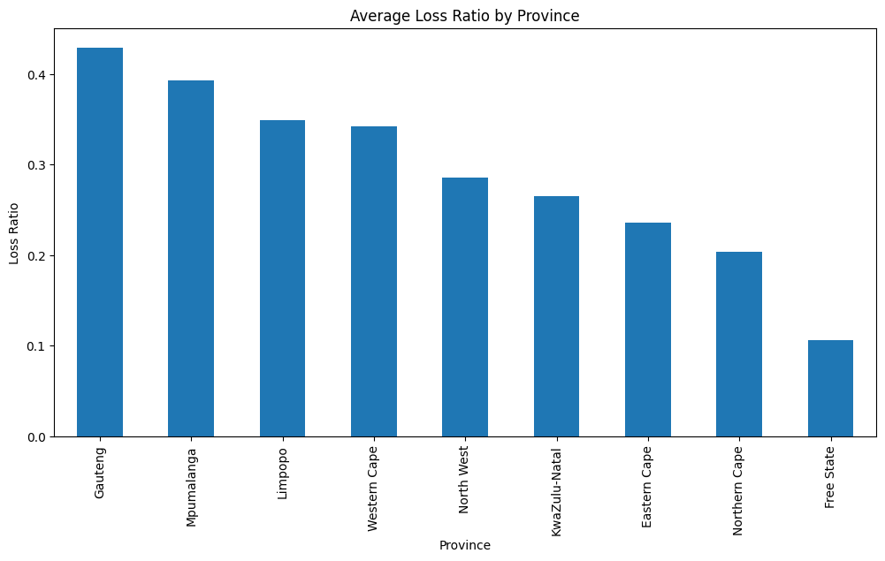
Figure 6 — Average Loss Ratio by Province. Gauteng and Mpumalanga are highest-risk; Free State and Northern Cape are most profitable.
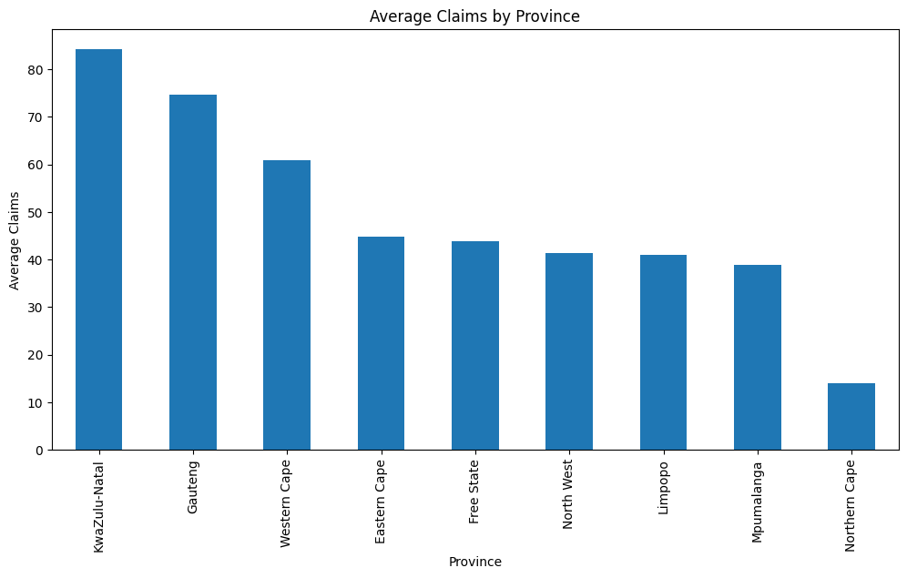
Figure 7 — Average Claims by Province. Urban provinces generate substantially higher average claim costs.
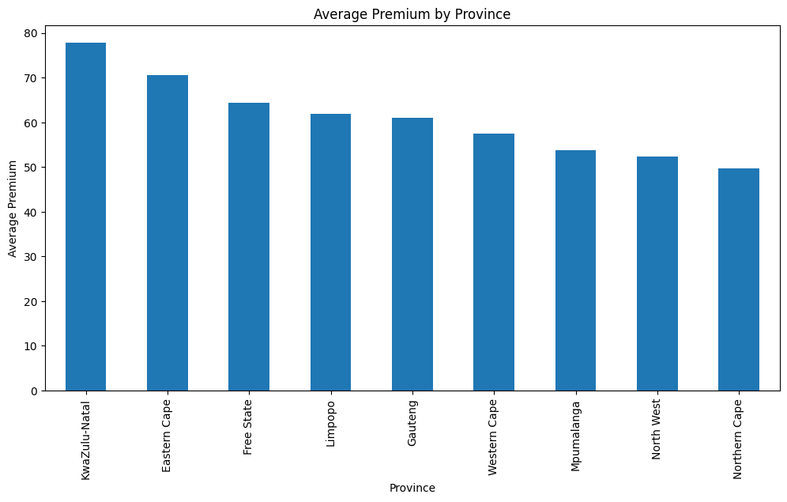
Figure 8 — Average Premium by Province. Premium distributions broadly align with claim differences, reflecting existing underwriting adjustments.

2.5 Bivariate & Multivariate Analysis

Correlation Matrix
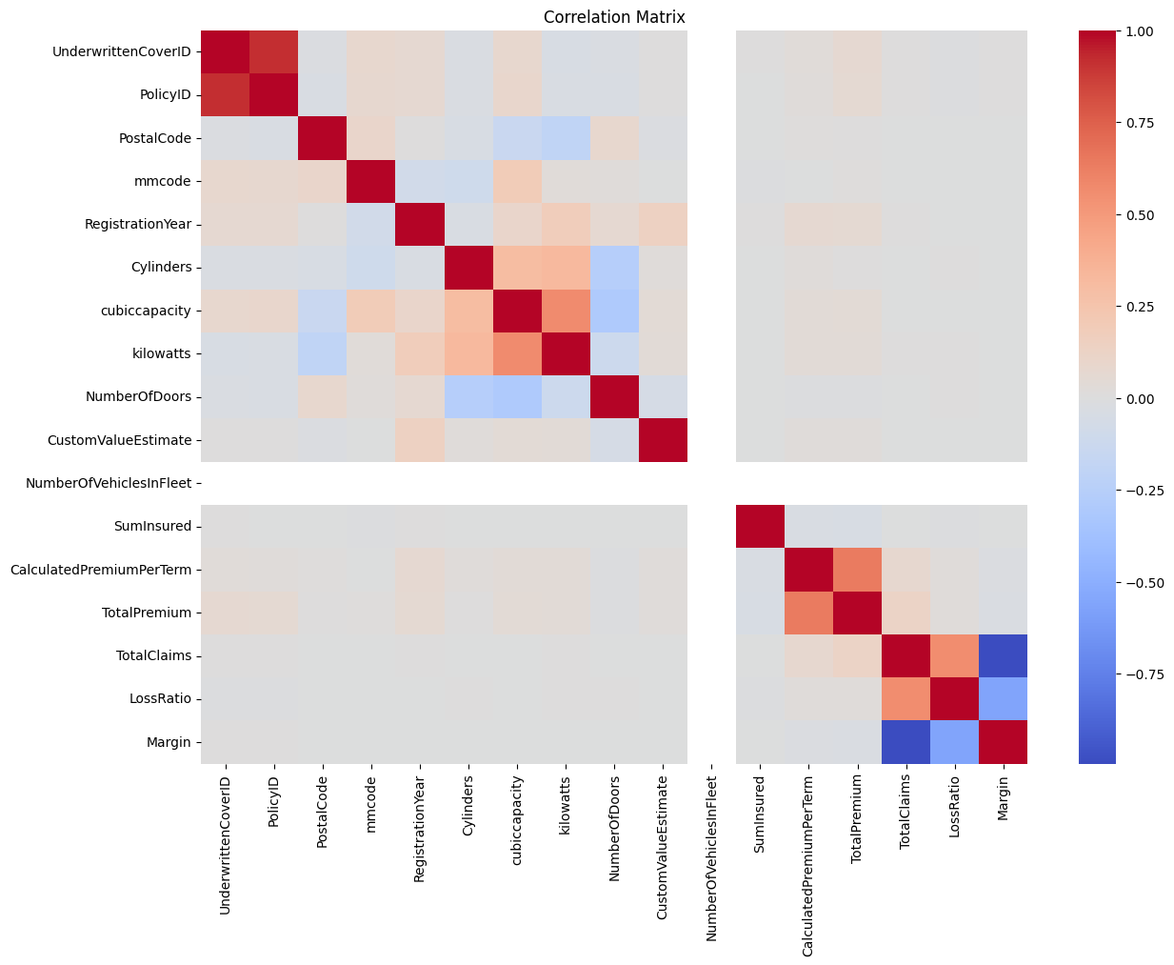
Figure 9 — Correlation Matrix. Premium-related variables are positively inter-correlated. Most variables show weak linear relationships overall, motivating the ensemble modelling approach planned for Task 4.

TotalPremium vs. TotalClaims
Most policies cluster at low values for both variables. A subset exhibits very large claims relative to premiums — the portfolio's primary financial risk concentration — confirming that a small number of policies drive a disproportionate share of total losses.
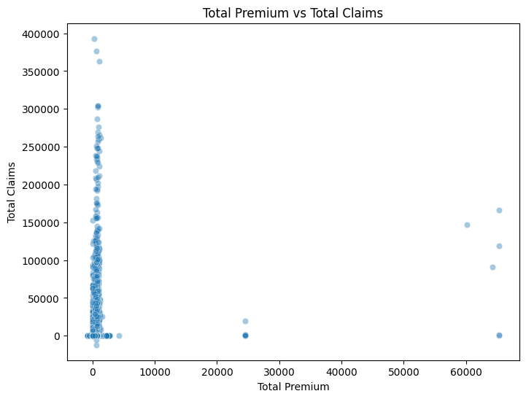
Figure 10 — Premium vs. Claims scatter plot. The cluster near the origin confirms skewed distributions; outlier policies with extreme claim-to-premium ratios are visible.

2.6 Temporal Trend Analysis
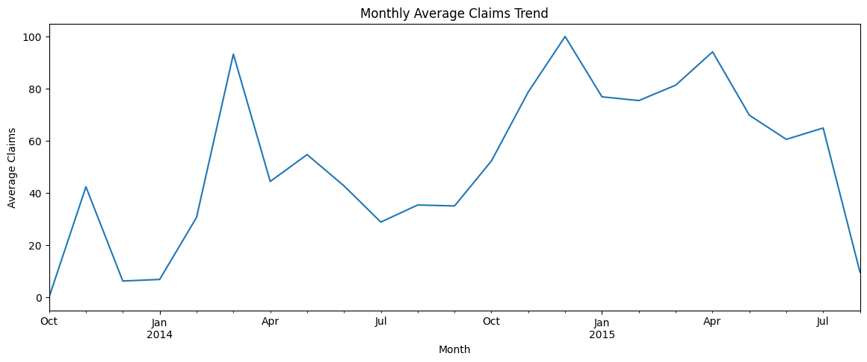
Figure 11 — Monthly Average Claims Trend. Month-to-month fluctuations suggest possible seasonal effects across the 18-month window.
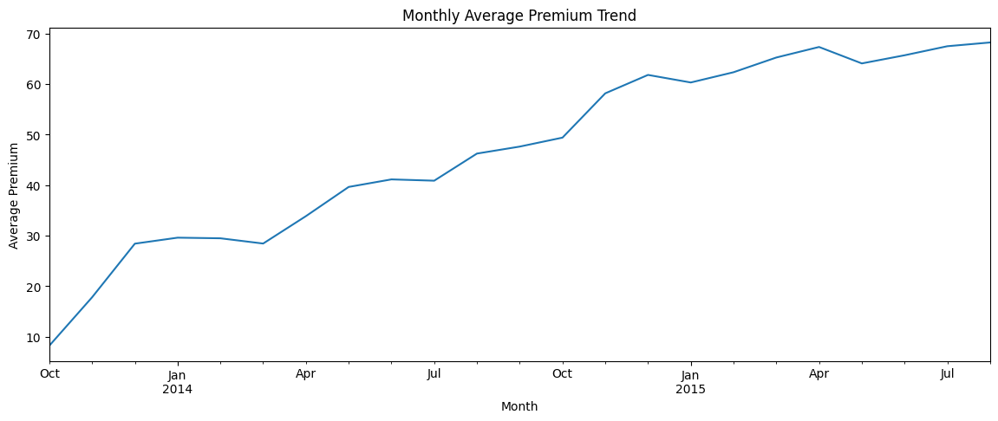
Figure 12 — Monthly Average Premium Trend. Premiums are comparatively stable, reflecting consistent policy pricing.
No structural break is evident; the dataset is suitable for pooled modelling. TransactionMonth will be included as a candidate feature in predictive models.

2.7 Segment-Level Loss Ratio Analysis
Loss ratio was computed across three segmentation dimensions, answering the guiding questions on Gender, VehicleType, and Province:

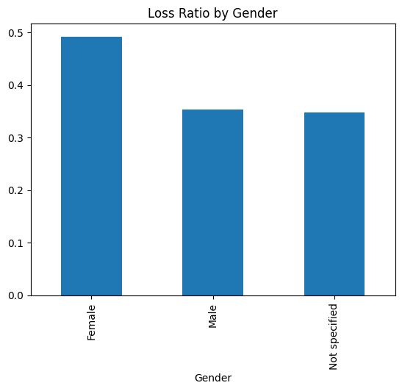
Figure 13 — Loss Ratio by Gender. Differences are present but modest; provides preliminary evidence for the gender hypothesis to be tested in Task 3.
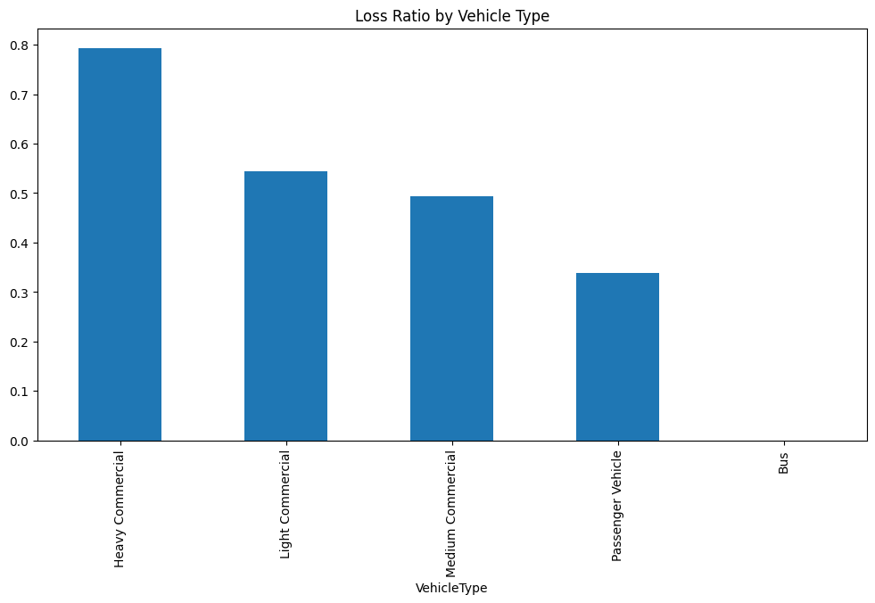
Figure 14 — Loss Ratio by Vehicle Type. Certain categories show loss ratios significantly above the portfolio mean, supporting differentiated vehicle-type pricing.
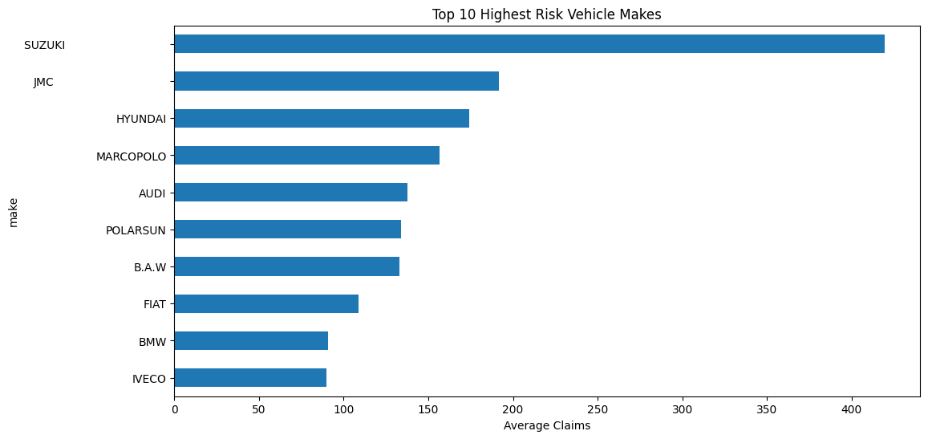
Figure 15 — Top 10 Highest-Risk Vehicle Makes by Average Claims. High-risk makes are associated with expensive parts or elevated theft profiles.

Summary of guiding questions answered:

Guiding Question | Finding
Overall Loss Ratio | ~0.35 — portfolio is profitable; ACIS collects roughly 2.9× total claims in premiums.
By Province | Gauteng/Mpumalanga highest; Free State/Northern Cape lowest (Figure 6).
By VehicleType | Significant variation — certain categories well above portfolio mean (Figure 14).
By Gender | Differences exist but are smaller than geographic or vehicle-type effects (Figure 13).
Outliers in Claims / Vehicle Value | Confirmed: genuine extreme observations present (Figures 4 & 5).
Temporal trends | Month-to-month claims fluctuation; premiums stable; no structural break (Figures 11 & 12).
Vehicle make risk | Top-10 highest-risk makes identified; significant spread in average claims (Figure 15).

3. Task 2: Data Version Control (DVC)
DVC was configured on the task-2 branch to establish a reproducible and auditable data pipeline — a standard requirement in regulated industries where every model result must be reproducible for regulatory review or debugging.

3.1 Setup & Configuration
Step | Outcome
dvc init | Initialised DVC in the project; created .dvc/ config directory and .dvcignore.
dvc add data/insurance_data.txt | Generated .dvc metadata file; data/.gitignore updated to exclude raw data from Git.
Local remote storage | Configured at ../dvc-storage via dvc remote add -d localstorage.
dvc push / dvc pull | Push confirmed (1 file pushed); pull confirmed successful recovery after deleting raw file.
Two data versions | Raw dataset tracked as Version 1; cleaned/preprocessed dataset committed as Version 2, demonstrating full versioning capability.
Git commits | .dvc files and .gitignore committed to Git — clean separation of code and data versioning.

3.2 Importance for Regulated Insurance Environments
- Every analysis result is tied to a specific data version, satisfying auditability requirements under South African insurance regulations.
- Large binary data files are excluded from Git, keeping repository size manageable while maintaining full traceability.
- Any team member or auditor can reproduce the exact data state by running dvc pull on the appropriate Git commit.

3.3 Reproducing the Pipeline
- git clone https://github.com/MahletBizunehBekele/insurance-risk-analytics.git && git checkout task-2
- pip install dvc && pip install -r requirements.txt
- dvc remote modify localstorage url /path/to/your/dvc-storage
- dvc pull → then run notebooks/01_eda.ipynb

4. Next Steps

4.1 Task 3 — A/B Hypothesis Testing
Four null hypotheses will be tested:

Hypothesis | Null Statement | Planned Test (α = 0.05)
H₀ 1 | No risk differences across provinces | Chi-squared (Claim Frequency) + t-test (Severity)
H₀ 2 | No risk differences between zip codes | Chi-squared (Claim Frequency) + t-test (Severity)
H₀ 3 | No margin differences between zip codes | Two-sample t-test on Margin
H₀ 4 | No significant risk difference between women and men | Chi-squared + t-test / z-test

4.2 Task 4 — Statistical Modelling
Two modelling goals will be pursued, with three algorithms each:
- Claim Severity Prediction — expected claim amount given a claim occurs.
- Optimal Premium Calculation — Premium = P(claim) × Predicted Severity + Expense Loading + Profit Margin.

Algorithm | Rationale
Linear Regression | Baseline; interpretable coefficients provide regulatory transparency.
Random Forest | Captures non-linear interactions; provides feature importance rankings.
XGBoost | Gradient boosting; strong performance on tabular insurance data.

SHAP or LIME will be applied to identify the most influential risk features and support explainability to regulators and business stakeholders.

5. Conclusion
The ACIS portfolio is profitable at a mean loss ratio of ~0.35, but profitability varies substantially across provinces, vehicle types, and manufacturers. Gauteng and Mpumalanga carry the highest loss ratios; Free State and Northern Cape are the most profitable. Financial variables are highly skewed with genuine outliers requiring robust modelling treatment. The DVC pipeline ensures full reproducibility and auditability of the data pipeline.

These findings provide a solid quantitative foundation for the hypothesis testing and predictive modelling phases that will translate EDA insights into actionable, evidence-driven pricing and segmentation recommendations for ACIS leadership.

GitHub | https://github.com/MahletBizunehBekele/insurance-risk-analytics | task-1 and task-2 merged into main

